A000-AM,S-Ecuador-Valdivia-Palmer Notched Anthropomorphic Stone Figurines Phase II-2600-2400 BCE

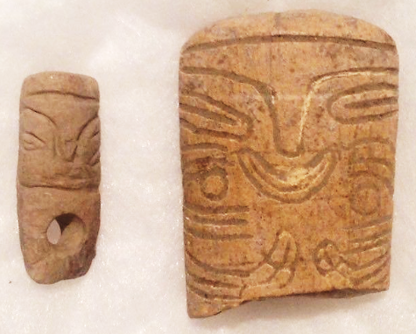 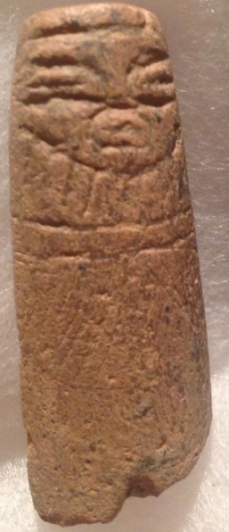 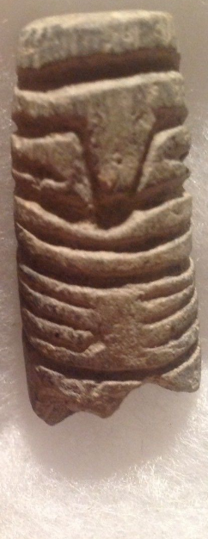

Figs. 1-4: Ecuador-Valdivia-Palmer notched Anthropomorphic Stone Figurines Phase II-2600-2400 BCE. Extremely Rare. Fig. 1. Mudstone. Face design (cap, eyes nose, mouth and chin) with conically drilled hole for suspension; Fig. 2. Rhyolite. Face design (cap, eyes nose, mouth face tattoos of three stripes and circles) with a three-tine rake-like design for hands and three parallel curving upwards lines for feet; Fig. 3. Face design (cap, eyes nose, mouth and chin); Fig. 4. Face design (cap, eyes nose, mouth and chin) with a three-tine rake-like design for hands.

**Case no.: 9**

**Accession Number:**

**Formal Label:** Ecuador-Valdivia-Palmer Notched Anthropomorphic Stone Figurines Phase II

-2600-2400 BCE

**Display Description:**

Valdivia Palmer-notched Anthropomorphic Stone Figurines are the earliest known human figurines in the New World. Palmer figurines evolved from simple rectangular plaques with a groove indicating the division between the legs but no head.

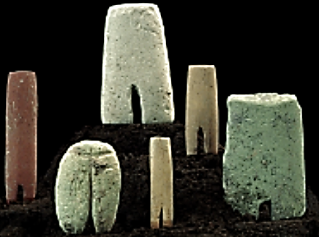

Palmer-notched Anthropomorphic Stone Figurines, Phase I, 3500-2600 BCE. After http://www.galeriacontici.net/wpimages/wp2578da64_06.png

Palmer notched Anthropomorphic Stone Figurines Phase II (2600-2400 BCE) above, expanded the stone prisms vertically adding facial features denoting caps, eyes, noses and mouths and depicted hands as three-tine, rake-like designs.

**LC Classification:**

**Date or Time Horizon:** 2600-2400 BCE

**Geographical Area:** Valdivia, Ecuador

**Map:**

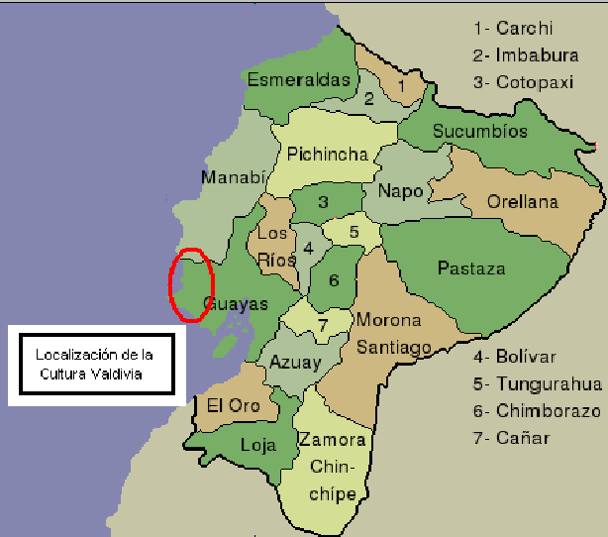

**Valdivia culture, Ecuador, after https://upload.wikimedia.org/wikipedia/commons/3/3b/Localizaci%C3%B3n_de_la_Cultura_Valdivia.PNG**

**GPS coordinates:**

**Cultural Affiliation:** Valdivia

**Media:** stone

**Dimensions:**

**Weight:**

**Condition:**

**Provenance:** Ex. B. Burns Collection New York, NY

**Discussion:**

Influences on Valdivia culture. Valdivia Ceramic phase A (to 3000-2700 BCE) was thought to be the oldest pottery of a coastal culture in South America. Then in 1962 Emilio Estrada, Clifford Evans and Betty Meggers having identified significant similarities between Valdivian ceramics and those of the  [Early to Middle Jomon culture](https://en.wikipedia.org/wiki/J%C5%8Dmon_culture) of Kyūshū, Japan, regarding incising, vessel shape and figurines (such as theBrooklyn Museum’s ceramic female figurine from Valdivia dating to 2600-1500 BCE suggested that Japanese fishermen on drift voyages carried by ocean currents had landed in Valdivia and introduced Jomon pottery to the Valdivians (Estrada, Meggers and Evans 1962).

Since the transpacific voyage of 15,000 km (8,000 nautical miles) would have taken a year and a half in dugout canoes and since Valdivia ceramics had developed independently, the transpacific voyage was foiled.

Since then, it is now thought that pre-Valdivian ceramic ideas were introduced from either the Puerto Hormiga site in northern Colombia or San Pedro style sites 5.6 miles (9 km) up the Valdivian river valley.

## References

Estrada, E; Meggers, BJ; Evans, C. 1962. "Possible Transpacific Contact on the Coast of Ecuador". Science. **135**: 371–2.

Evans, Clifford; Meggers, Betty (January 1966). "A Transpacific Contact in 3000 BC", Scientific American, **214** (1): 28.

Valdivia 8 (Piquigua Phase) Atahualpa site Ecuador. Succeeds the Palmar Incised type. Ultra Rare near choice stone. Monolith stone block in bas-relief embellished with deep excised carvings on all six sides. Two trapezoid, two rectangular and two square  sides. Overseeing the cosmos from all directions. These types of Valdivian stones are probably the most purest abstraction of human form. Outstanding piece. 3000 - 1450 BC. Measures 10" in height

Similar examples published in Ancient Ecuador - Culture, Clay and Creativity 3000-300 B.C. Also appear at Casa del Alabado Museum of Pre-Columbian Art, Quito, Ecuador.

Appendix:

